**DATA STRUCTURE LAB**



**LAB REPORT: 01**

|  |  |
| --- | --- |
| **Name** | ZAHRA MOBEEN |
| **Registration Number** | 200901102 |
| **Batch & Section** | CS(01)-A |
| **Assignment Number** | 01 |
| **ASSIGNMENT** | DATA STRUCTURE |
| **Submitted to:** | SIR NADEEM |
| **Date of Experiment** | 22ND OCT, 2021 |

**TASK#01**

Write a program to let the user enter a string of his own choice. Check whether the given string is a palindrome or not.

Sample Input: LEVEL

Output: Given string is Palindrome

Sample Input: LEVELL

Output: Given string is not Palindrome

**ANSWER:**

|  |
| --- |
| a= input("enter a string:")  b=""  for i in a:    b=i+b    print("Appending:",i)  if(a==b):    print("Given string is palindrome")  else:      print("Given string is not palindrome") |

**OUTPUT:**

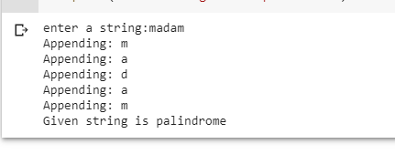

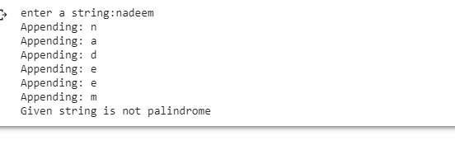

**TASK#02**

Write a program to check the balanced parenthesis in the expression or not using stack:

**ANSWER:**

|  |
| --- |
| def Balanced(a):      b = ['()', '{}', '[]']      while any(x in a for x in b):          for c in b:              a = a.replace(c, '')      return not a  i =  input("enter a Brackets")  print(i, "-", "Balanced"        if isBalanced(i) else "Unbalanced") |

**OUTPUT:**

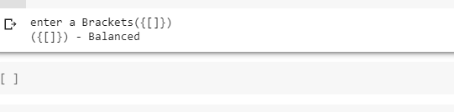

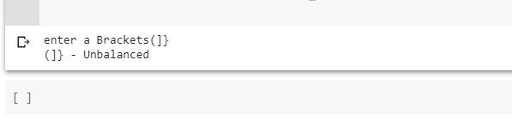

**THE END**